Experiment 2: write a Python program to solve the 8-Queen Problem

Aim
To write a Python program to solve the 8-Queen Problem using the Backtracking algorithm.

Algorithm
- Start placing queens from the first column.
- Check whether the current position is safe.
- If safe, place the queen.
- Move to the next column.
- If no safe position is found, backtrack to the previous column.
- Repeat until all 8 queens are placed.
- Display the chessboard with queen positions.

Program
N = 8

board = [[0 for i in range(N)] for j in range(N)]

def is_safe(row, col):

for i in range(col):
if board[row][i] == 1:
return False

i = row
j = col
while i >= 0 and j >= 0:
if board[i][j] == 1:
return False
i -= 1
j -= 1

i = row
j = col
while i < N and j >= 0:
if board[i][j] == 1:
return False
i += 1
j -= 1

return True

def solve(col):

if col >= N:
return True

for i in range(N):

if is_safe(i, col):
board[i][col] = 1

if solve(col + 1):
return True

board[i][col] = 0

return False

if solve(0):
print("Solution:")
for row in board:
print(row)
else:
print("No Solution")

Output
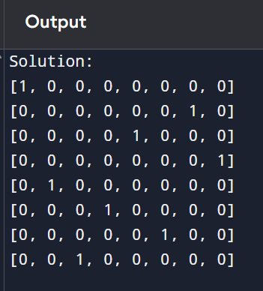

Result
Thus, the Python program to solve the 8-Queen Problem using the Backtracking algorithm was implemented successfully and the solution was obtained.

